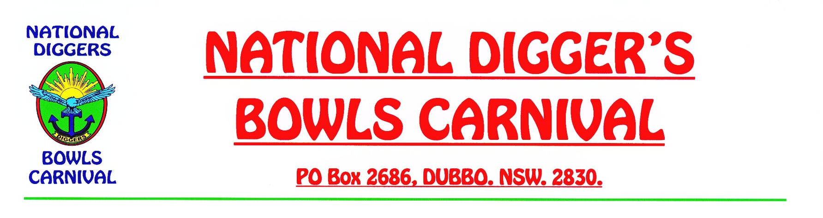

**UPDATE 2019**

AS MOST OF YOU WOULD HAVE HEARD BY NOW OUR DUBBO RAILWAY BOWLING CLUB WENT INTO VOLUNTARY LIQUIDATION AND HAS CLOSED DOWN LAST FEBRUARY.

AS A RESULT THIS YEAR THE DUBBO CITY BOWLING CLUB, WHICH HAS BEEN TAKEN OVER BY OUR DUBBO RSL MEMORIAL CLUB, HAVE KINDLY OFFERED THEIR BOWLS FACILITIES, SO THAT WE CAN CONTINUE TO RUN OUR CARNIVAL ALONG WITH CLUB DUBBO WHO CONTINUE TO REMAIN OUR CO-HOSTS. WE THANK THEM BOTH FOR THEIR KIND GENEROSITY.

ALL ACTIVITIES WHICH WERE HELD AT THE RAILWAY B/C WILL NOW BE ON OFFER AT DUBBO CITY B/C, WHICH IS LOCATED AT 72 WINGEWARRA STREET AND IS CONTAINED IN THE VICTORIA PARK PRECINCTS IN THE MIDDLE OF TOWN, NOT TOO FAR AWAY FROM THE FORMER RAILWAY B/CLUB.

THIS BOWLING CLUB IS NEAR THE WESTERN PLAINS CULTURAL CENTRE AND JUST A SHORT WALK AWAY FROM THE DUBBO RSL MOTEL UP ALONG WINGEWARRA STREET.

THE DUBBO CITY B/C HAS THREE FINE GREENS AND ALL THE FACILITIES YOU WOULD EXPECT FROM A MODERN DAY BOWLING CLUB. WE HOPE THAT YOU WILL NOT BE PUT OUT BY THE CHANGE OF VENUE AND WE GUARANTEE YOU WILL ALL ENJOY YOURSELVES AS USUAL. ALL OUR USUAL ACTIVITIES WILL REMAIN THE SAME AS WILL THE COMRADERIE.

YOURS IN BOWLS

ERIC CHAMBERLAIN

SECRETARY

NDBC