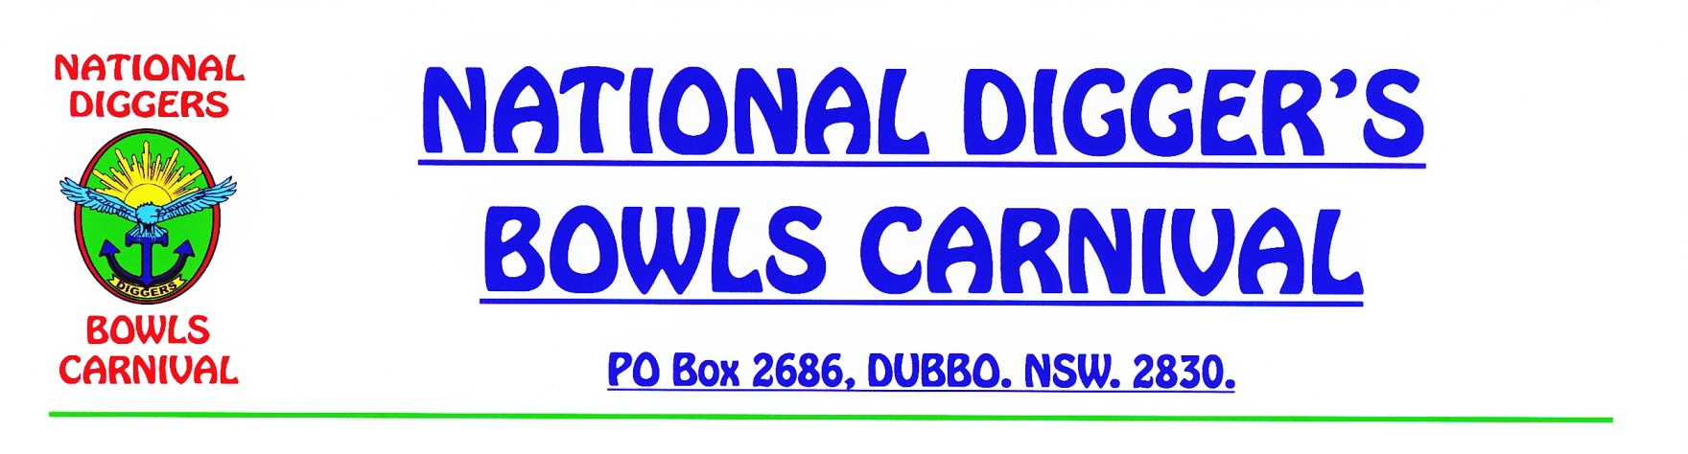

# PROGRAM OF EVENTS 2019

**1. MONDAY 9/9/2019.**

2PM - 8PM

REGISTRATION OF TEAMS & PLAYERS, AT **CLUB DUBBO**.

ISSUE OF DRAW & NAME TAGS. **(WEST DUBBO BOWLING CLUB)**

**PRACTICE ROLLUPS AVAILABLE AT BOTH CLUBS.**

**THE COMMEMORATION SERVICE WILL NOW BE HELD AT EACH CLUB PRIOR TO THE COMMENCEMENT OF PLAY.**

**2. TUESDAY 10/9/2019.**

8.45AM – COMMEMORATION SERVICES AT EACH OF THE CLUBS.

9AM – SECTIONAL PLAY COMMENCES AT BOTH BOWLING CLUB VENUES.

3 GAMES OF 15 ENDS ON 1st DAY.

**3. WEDNESDAY 11/9/2019.**

9AM – PLAY COMMENCES AT BOTH BOWLING CLUB VENUES.

2 GAMES OF 15 ENDS + PRELIMINARY FINALS AT EACH CLUB ON 2nd DAY.

**4. THURSDAY 12/9/2019.**

9AM – PLAY COMMENCES AT FINALS VENUE - **DUBBO CITY B/C**.

&CONSOLATION SERIES TO BE PLAYED AT **BOTH BOWLING CLUBS.**

6PM – PRESENTATIONS AT **DUBBO CITY B/C.**

**BECAUSE OF THE PROSPECT OF AN ODD NO. OF ENTRIES, THERE MAY BE A BYE IN ONE OR MORE SECTIONS. (DUE TO CANCELLATIONS ETC.)**

IF THERE ARE ANY BOWLERS WISHING TO TAKE ADVANTAGE OF DUBBO’S TOURIST ATTRACTIONS THERE WILL BE SOCIAL BOWLS AT BOTH BOWLING CLUBS ON THE FRIDAY, SATURDAY & SUNDAY PRIOR TO & AFTER THE CARNIVAL.

**DUBBO MACQUARIE DIGGER’S DAY ON SUNDAY 8/9/2019. (NOM. FORM ATTACHED)**

**LOCATIONS:**

DUBBO CITY BOWLING CLUB - 72 WINGEWARRA STREET, DUBBO.

CLUB DUBBO BOWLING CLUB (WEST DUBBO) - WHYLANDRA STREET, WEST DUBBO.

**PLEASE ENJOY YOUR BOWLS AND RETURN NEXT YEAR.**

Eric Chamberlain

Secretary

Dubbo Railway Digger’s Section