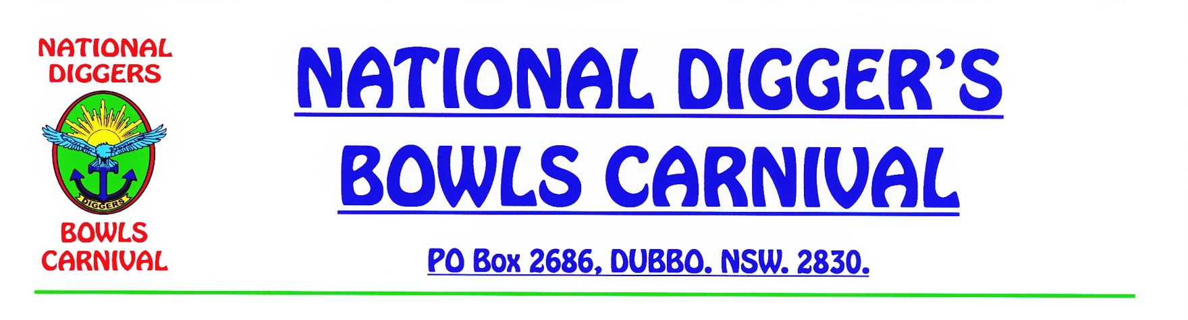

**NOTICE BOARD**

**NEXT YEAR’S DATE**

TUESDAY, WEDNESDAY & THURSDAY

**15th, 16th & 17th SEPTEMBER, 2020.**

ENTRY NOTICES WILL GO OUT LATE MARCH, 2020.

**COMMEMORATIVE SERVICE**

THE USUAL SERVICE HELD AT THE CENOTAPH WILL NOW BE HELD AT EACH CLUB PRIOR TO COMMENCEMENT OF PLAY.

**TAXI VOUCHERS**

ARE AVAILABLE TO PLAYERS FROM EACH HOST CLUB

THEY MUST BE USED FOR YOUR HOME TRIP TO YOUR

ACCOMMODATION ONLY, AND TO THE VALUE OF $15.00.

**DUBBO CITY BOWLING CLUB - TBA**

**CLUB DUBBO - $5.00**

**PETER BEETHAM MEMORIAL SHIELD**

FIVE YEARS AGO WE HAD THE UNFORTUNATE PASSING OF PETER BEETHAM OF TAREE WHILST HE ATTENDED OUR CARNIVAL, SO WE HAVE NAMED THE ‘CONSOLATION COMPETITION’ IN HONOUR OF OUR FALLEN MATE.

**DUBBO MACQUARIE DIGGERS DAY**

WE ARE HAVING THE ANNUAL DIGGERS DAY AT THE MACQUARIE BOWLING CLUB ON THE SUNDAY PRIOR TO THE CARNIVAL. IF YOU WOULD LIKE TO PARTICIPATE THERE IS A NOMINATION FORM ATACHED TO THE MAILOUT TO THE TEAM REPRESENTATIVES, OR CONTACT CLUB ON 02 6882 1019.

I HOPE YOU ALL HAVE A GOOD TIME AND YOU ALL ENJOY YOURSELVES.

ERIC CHAMBERLAIN

SECRETARY